Subscribe to DeepL Pro to edit this document.
Visit www.DeepL.com/Pro for more information.

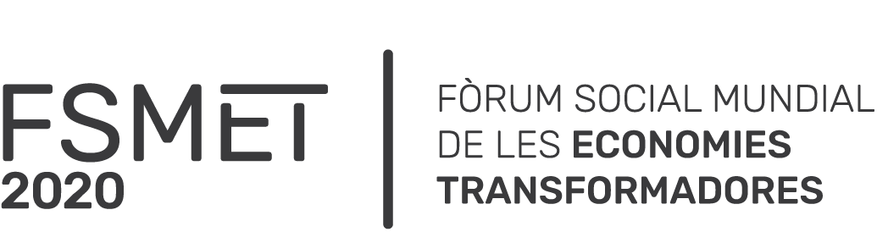

Meeting # 20
Confluence Public Policies of the Transforming Economies,
February 16, 2021
FSMET | 2019-2020

World Social Forum on Transformative Economies - Barcelona 2020
Public Policy Group Meeting
Tuesday 16 February 2021

Participants:

- Yvon Poirier, Réseau intercontinental de promotion de l'économie sociale solidaire (RIPESS) Québec
- Jason Nardi, Intercontinental Network for the Promotion of the Social Solidarity Economy (RIPESS) Italia
- Julie Hernandez, Intercontinental Network for the Promotion of the Social Solidarity Economy (RIPESS) Barcelona
- Alfonso Cotera, Intercontinental Network for the Promotion of the Social Solidarity Economy (RIPESS), Perú
- Sergi Corbalán, Fair Trade- Advocay, Brussels
- Xavi Rubio, Barcelona City Council
- Maria da Penha Lage Camargo, Red de Gestores de Políticas Públicas Economía Social Solidaria, Brazil
- Luis Alfredo Vargas, Unicossol Network Colombia
- Maria Atienza, Network of Networks of Alternative and Solidarity Economy, Navarre
- Andrea Rodriguez, FSM Transformative Economies, Barcelona, Spain
- Alicia Cabezudo, Campaign for Global Curriculum, International Peace Bureau - IPB
- Alejandro Tombesi, Campaign for Global Curriculum, Buen Vivir Campaign, Argentina
- Claudia Rubiela, Campaign for Global Curriculum, Buen Vivir Campaign, Argentina
- Marisol Lage Torres, Diputacio de Barcelona, Catalunya
- Xavi Ferrer, Dos mes dos cinc, Barcelona
- Hans Cediel, Foro social de economías transformadoras y alternativas Colombia - Lat, Indesco Universidad Cooperativa de Colombia
- Noelia Delgado, Quebec

Agenda

05  minutes | 15h - 15h05 | Welcome and tour of participants and presentation of agenda
05  minutes | 15h05 - 15h10 | Main points meeting November 24, 2020
05  minutes | 15h10 - 15h15 | Main points of the systematization of the actions of the Public Policy confluence
minutes | 15h15 - 15h40 | Reflect on and evaluate our contribution to the FSMET process.
05  minutes | 15h40- 15h45 | Send a document to Maria de REAS of the FSMET coordinating committee with the result of our evaluation.
minutes | 15h45-15h55 | Forum - Cities for Change
05  minutes | 15h55 - 16h | Conclusions / Date of the next meeting

Subject | Main elements discussed
1.Welcome and tour of participants and presentation of agenda | The participants agree to the agenda for February 16, 2021.
2.Main points meeting November 24, 2020 | The main points of the meeting are mentioned:  - To request and commit at the next meeting of the FSMET coordination committee, the participation of the representatives of the different transforming economies in the next meeting of the confluence of public policies.
3. Main points of the systematization of the actions of the Public Policy confluence | The purpose of this report is to systematize the actions that have been carried out during the 2 years of the FSMET process, as well as the systematization of the results based on the objectives set as a group.  - Number of meetings: 18  - Frequency of meetings: monthly  - Average attendance: 15 organizations  - Participating profiles: local public institutions, international networks, local organizations, international organizations  - Participation in key moments of the FSMET: Convergence Meeting April 2019, International Networks Meeting July 2019, Virtual FSMET June 2020, FSMET Confluence Meeting November 2020, FSMET 2021.
4. Reflect and evaluate our contribution to the FSMET process. | Participants analyze the contribution of the confluence of Public Policies, the main elements of this discussion are the following:  - The contribution of the confluence of Public Policies is a collective heritage of investment of all local public institutions, international networks, local organizations, international organizations.  - The general objective of the confluence has been achieved to a large extent, however, the purpose as a transversal axis, which is to build in concert with ALL the transforming economies that participate in this collective process, has not been achieved.  - It was not possible to establish dialogue and active listening to the agendas of the other transforming economies committed to their development.  - The strength of the Public Policy confluence is the successful implementation of the different activities. Its weakness is reflected in the transformation of energy and synergy after June due to the context.  - We must identify some common action with which we all identify. Generate an instrument that allows us to collect the different practices. The Social and Solidarity Economy includes many forms of transformative economies.  - Analyze how we contact other Social and Solidarity Economy organizations at the local level.  - The Public Policy confluence must have the capacity to read the conclusions of the different confluences. We must translate these conclusions into an agenda.  - We must evaluate what are our future landing strips of this confluence: GSEF 2021, share experiences with organizations from different territories.  - To value that our confluence has created a lot of synergy in the reflection of public policies at the local level. We need to value how to work on public policies at different levels, such as the Ministry of Labor and Social Economy.
5. Forum - Cities for Change | Xavi Ferrer presents the Forum Cities for Change.  The Amsterdam forum will start at the end of March and run until the end of May. It will be a decentralized event, with different cities and towns holding their own forum on a date that suits them. The forum will focus on social, ecological and democratic transition and local welfare.  Working groups for the program.  - We are working on governance: the local groups would decide autonomously  - would decide on the program, communication, etc. + coordination meetings for common things.  - We are exploring how affinity groups see this. What would be important to them?  How does it align with your programs and agendas?  - We would like to organize the Forum as a real open process, like for example the WSF.  - The online participatory platform is being developed with Decidim software.  - Hybrid program, between online and offline. This mix offers a more playful and flexible character, a kind of political festival with room for more creativity to show our ideas.
6.Conclusions | Main conclusions of the meeting:  - To give continuity to the confluence of Public Policies  - To accept Xavi Ferrer's invitation to participate in the Cities for Change Forum and to request an appointment on March 2 with the Forum team in order to evaluate how to capitalize on the work done by the confluence on the theme of Public Policies and Transformative Economies.  - Welcoming the proposal of RIPESS and its willingness to continue working in order to listen, support and learn from different experiences such as those of Latin American colleagues, we must assess how to sustain and continue the work of the confluence of Public Policies.  - Organize an upcoming meeting of the Public Policy confluence on March 16 to discuss:  - participation of the confluence of Public Policies in Forum Cities for Change  4.2 continuity of the confluence of Public Policies to continue learning from different experiences (multidimensional level)  4.3. recomposition of the space, passing the baton, new leaderships being as transversal as possible and following the lines of what the participants have expressed.
7. Next meeting | Tuesday, March 16, 2021 at 3 p.m. Barcelona / 9 a.m. Montreal

